Lab 3 prelab

Part I:

1. 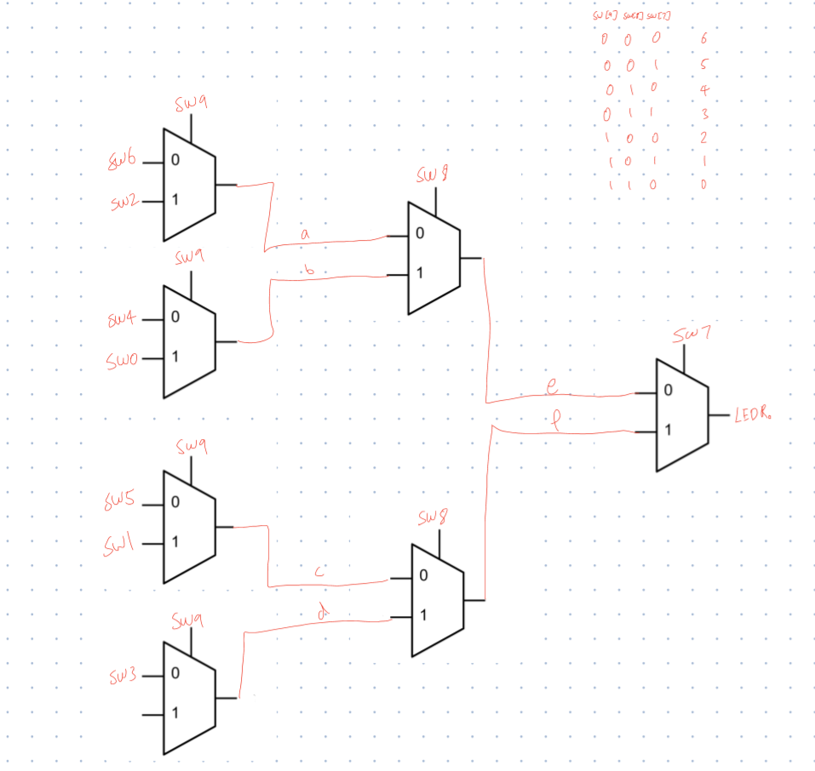

Schematic for 7to1 multiplexer

1. Submitted mux7to1.v on Quercus
2. 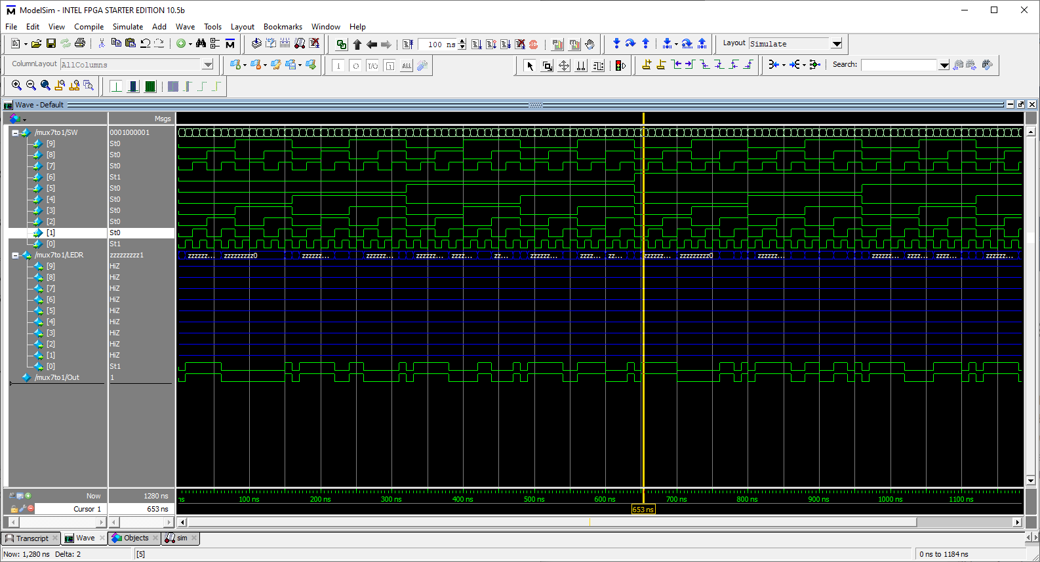

Simulation of 7to1 multiplexer.

Part II:

1. 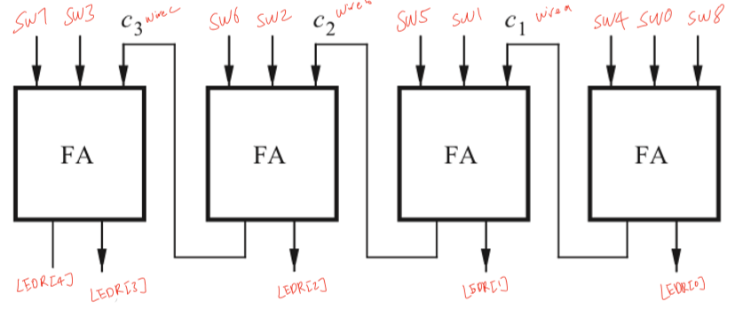

Schematic of 4-bit ripple carry adder

1. Verilog modules submitted on Quercus.
2. 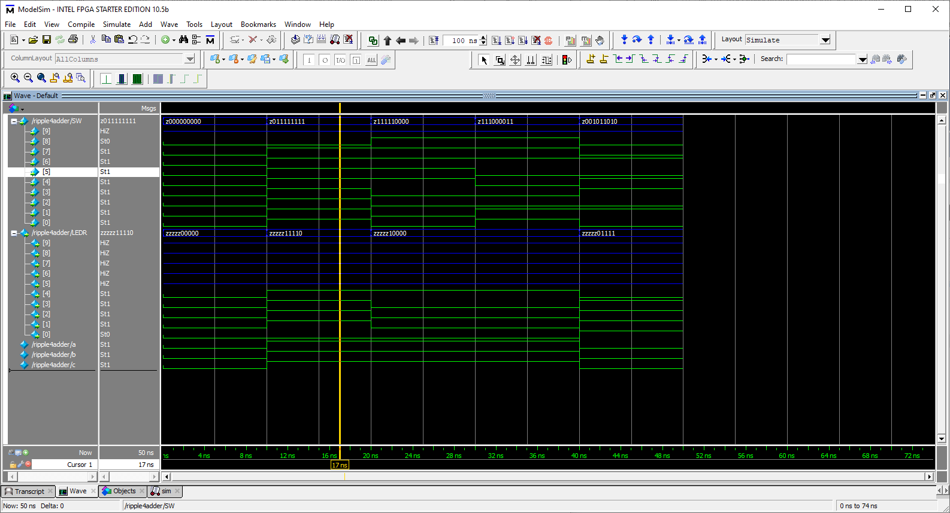

Simulation for 4-bit ripple carry adder. Test cases tested that the carry was working, and that circuit was not carrying unintentionally.